RPA is a way to automate repetitive and often rule based processes.

It records actions a human does to complete a computer based process and replicate those actions as many times as necessary. Error free and fast.

Employees can focus on creativity, judgement and personal interaction. It gives organization the flexibility to automate the front end.

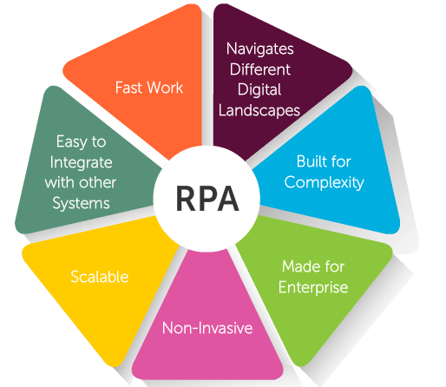

**Business benefits of RPA:**

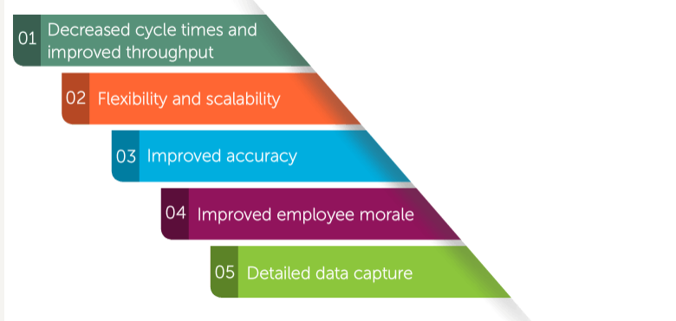

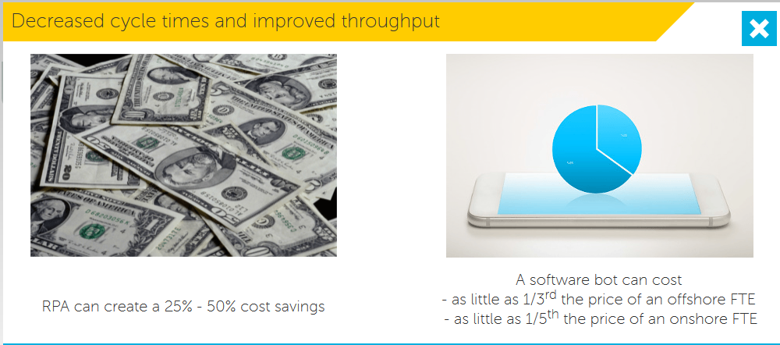

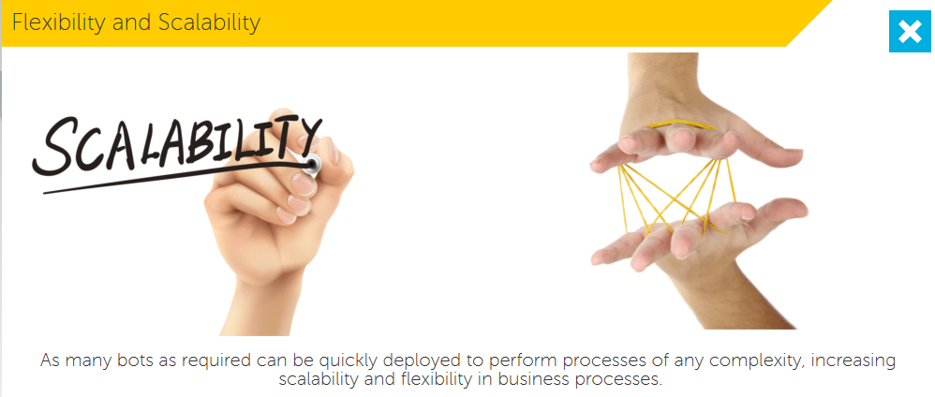

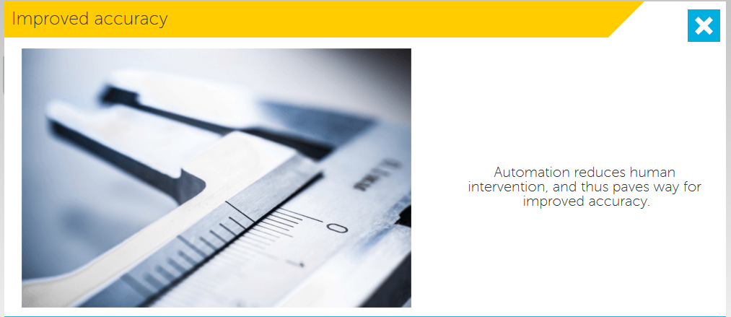

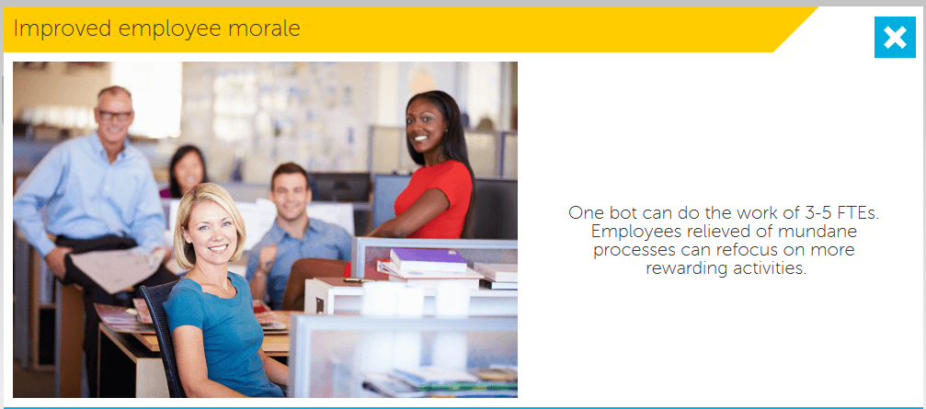

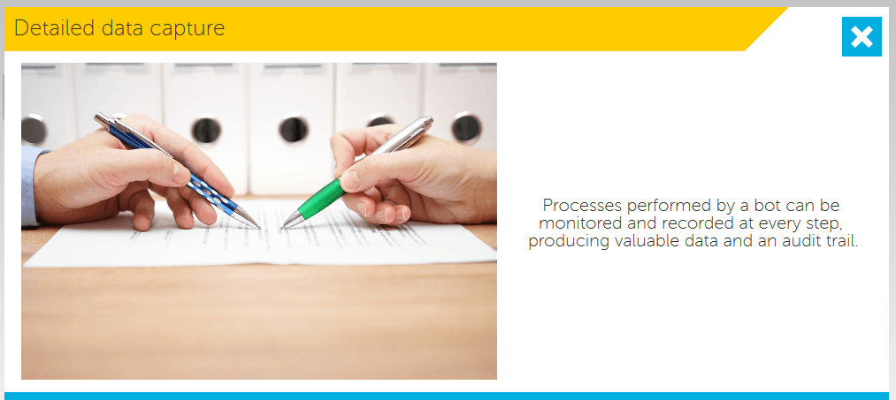

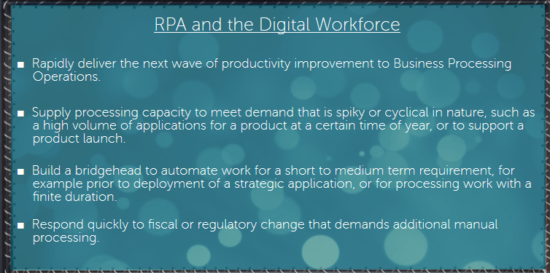

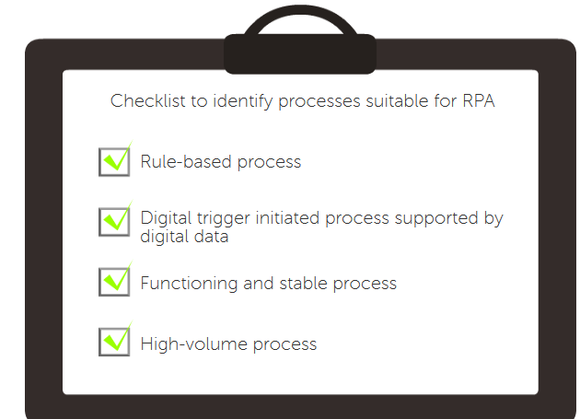

**Usage of RPA:**

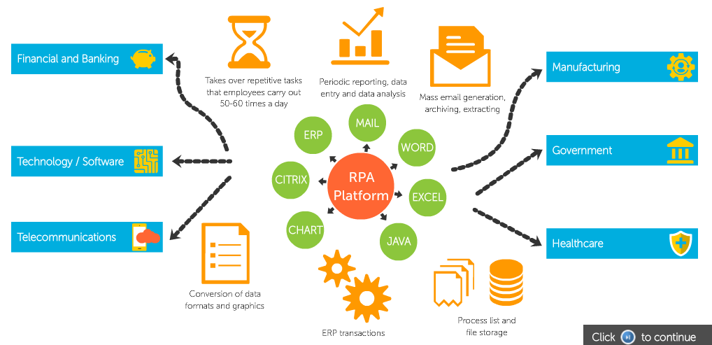

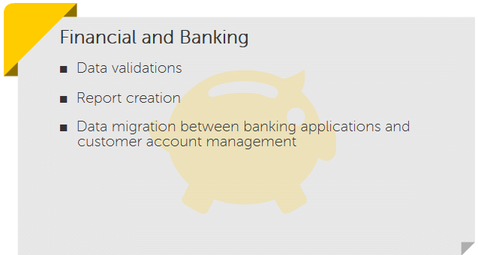

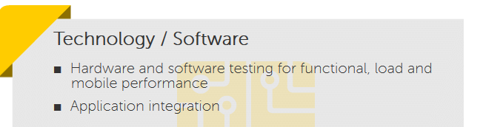

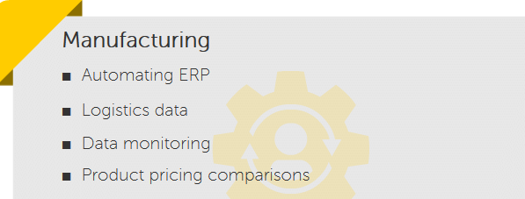

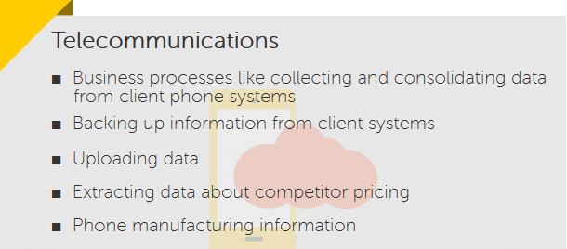

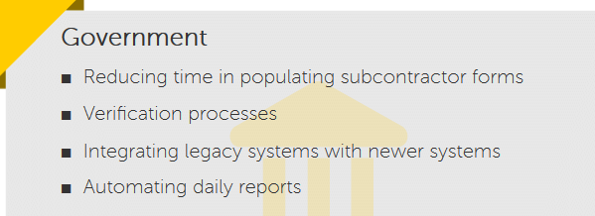

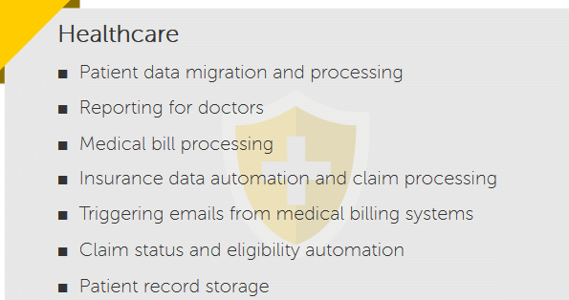

**Automation Anywhere can automate even the most complex processes.**

**What is Automation Anywhere?**

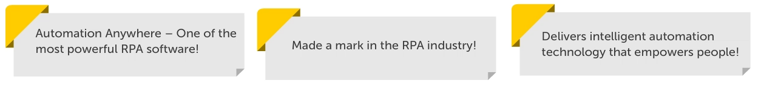

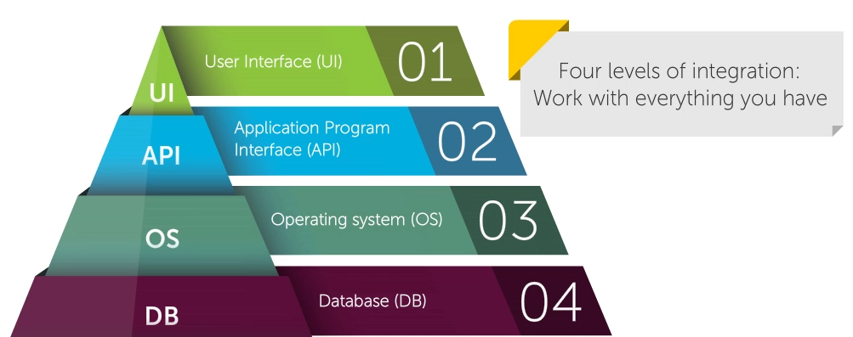

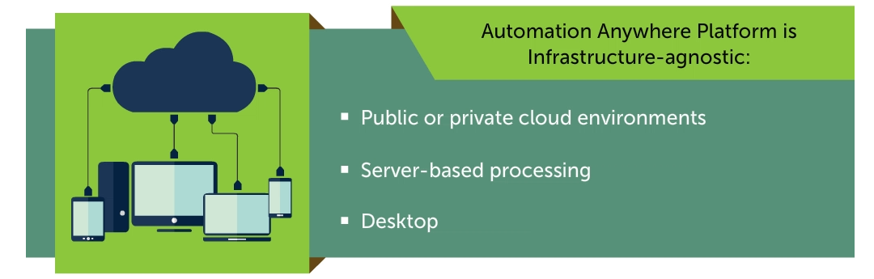

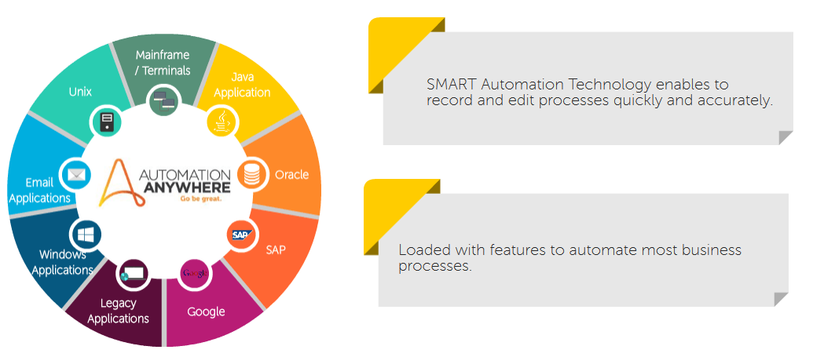

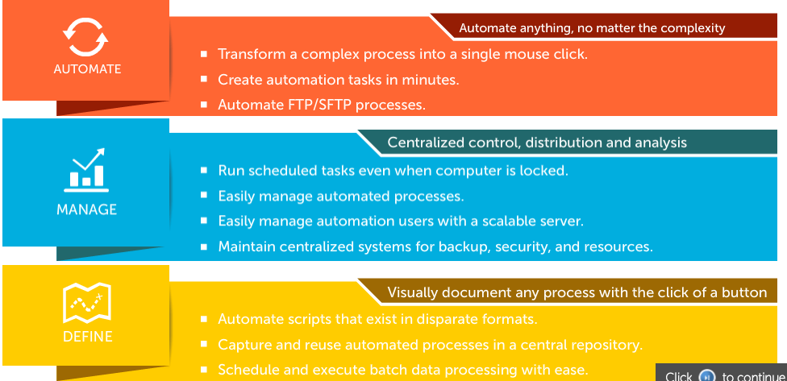

**Architecture:**

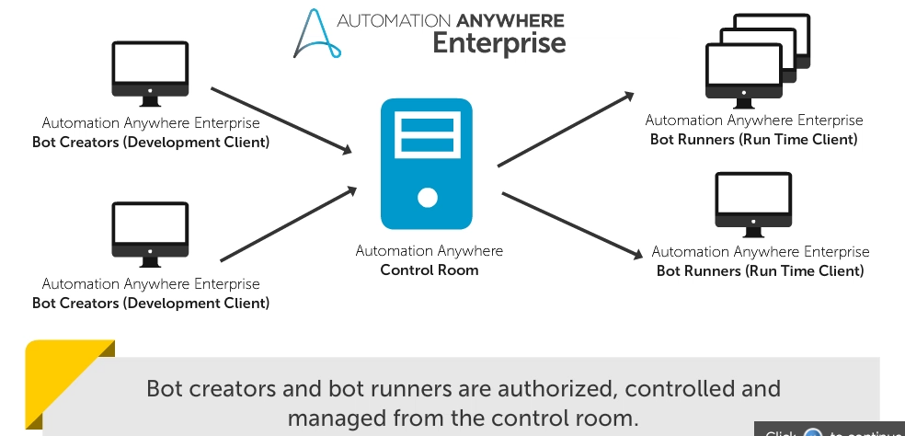

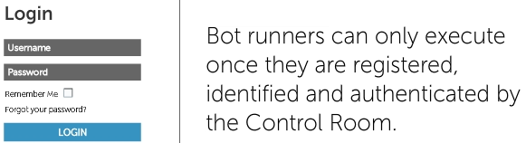







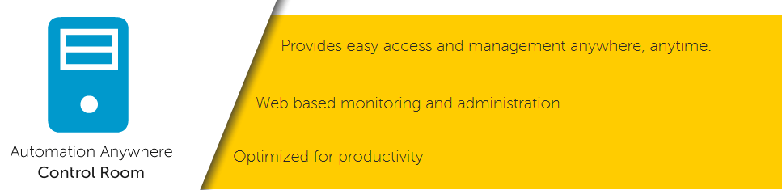

3 types of recorder:

1. Smart Recorder
2. Screen Recorder
3. Web Recorder

Overview of features:

**DashBoard**:

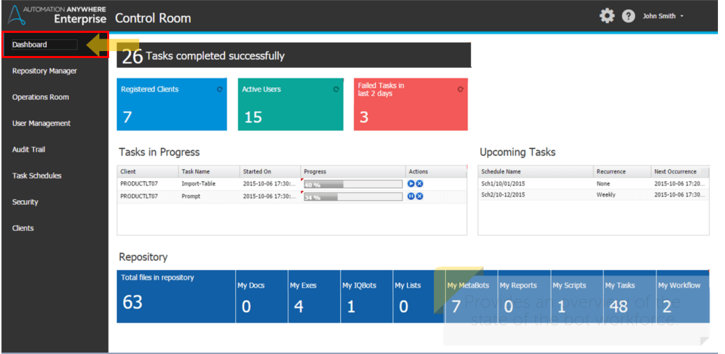

Provides an overview of the state of the bot workforce.

Enables monitoring of upcoming bots, bot’s schedules, details of bot in progress.

**Repository Manager:**

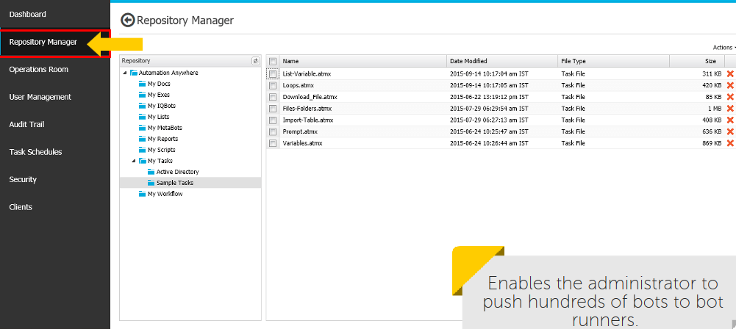

It shows the number of active bots and bot runners in the repository with demarcation for the file type.

**Operation Runners:**

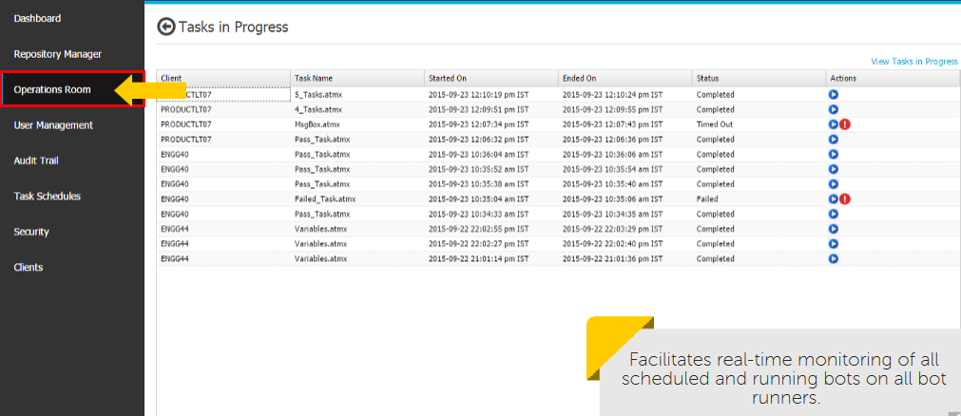

1. Enables manual distributions of bot workloads onto multiple bot runners for faster execution and load balancing.
2. Shows all bots, the user of each bot, IP address and application path as well as schedule credentials.

**User Management:**

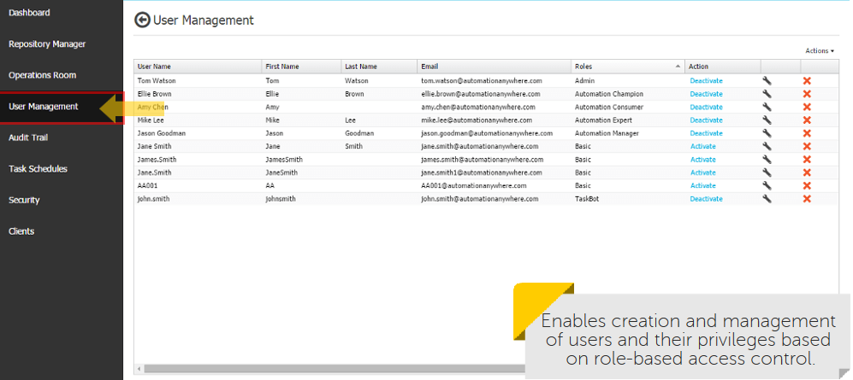

**Task Schedules:**

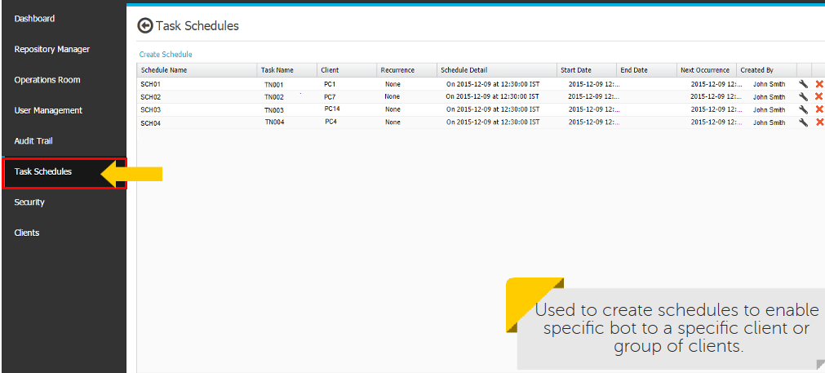

Allows to select a group and deploy multiple bots to a group of clients with a single click.

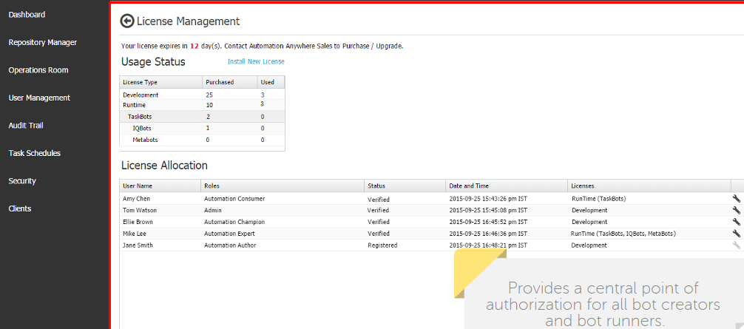

Automation Anywhere has 3 recorders:

1. Smart recorder.
2. Screen recorder.
3. Web recorder.

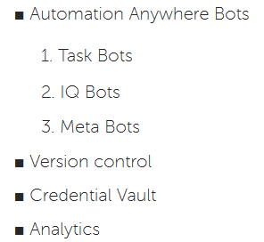

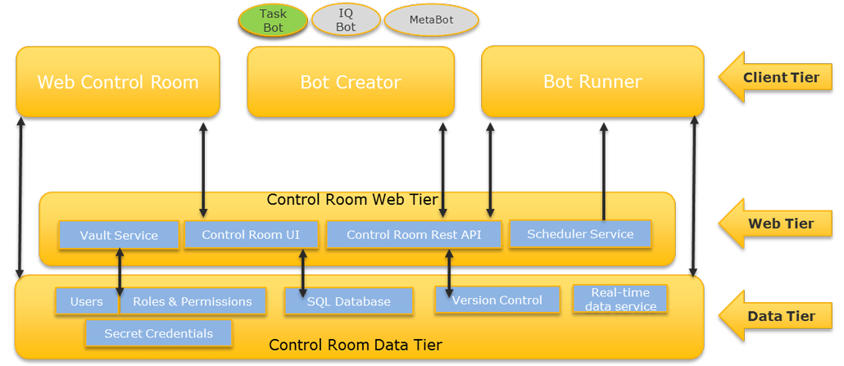

**Task Bots:**

1. Responsible for execution of task and form the base for all automation anywhere functions.
2. Executes repetitive, rule-based tasks that rely on structured data.
3. Easier to build and resilient to change.

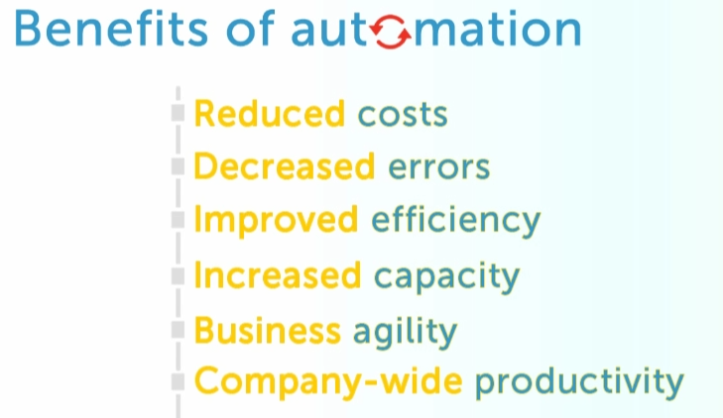

**IQ Bots:**

1. Next generation intelligent bots.
2. Allows developers to add cognitive capabilities to processes.
3. IQBots with vision skills: 1st step towards cognitive RPA.
4. It extracts information from semi and un-structured data. Learns and grows smarter with every human validation.

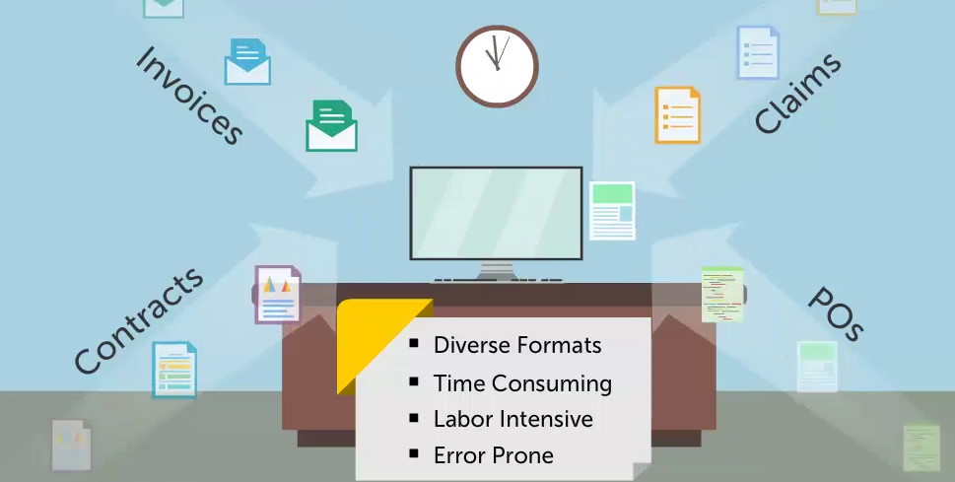

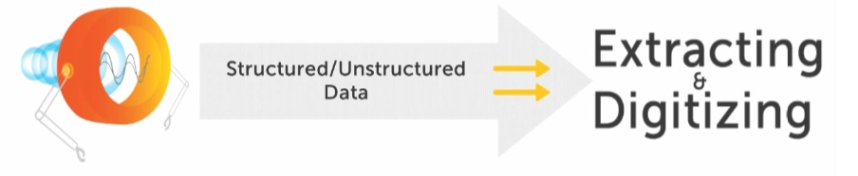

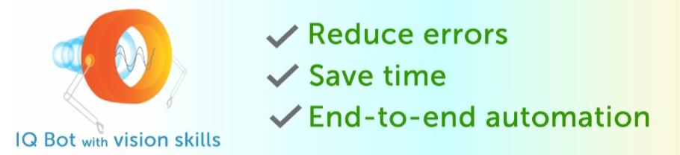

**Benefits of MetaBots:**

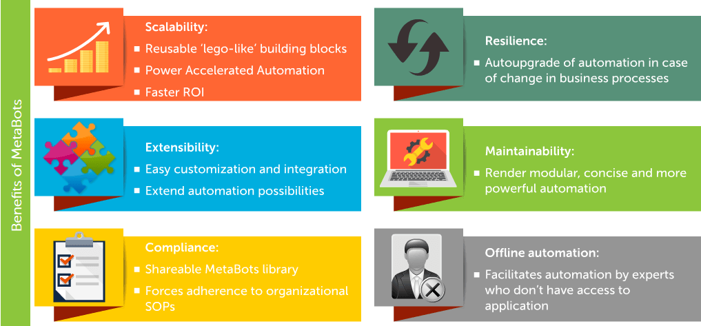

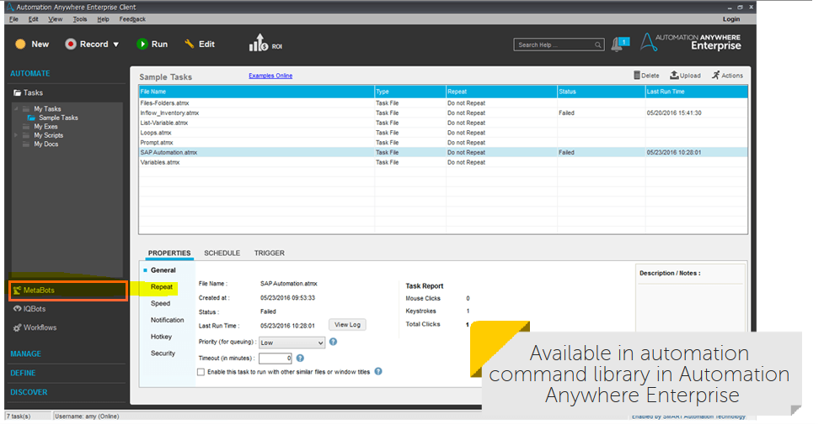

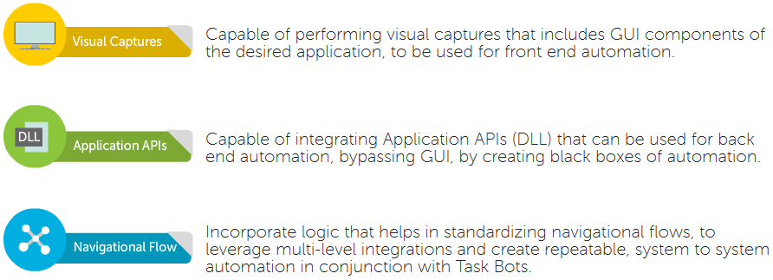

MetaBots are created and managed by MetaBot Designer.

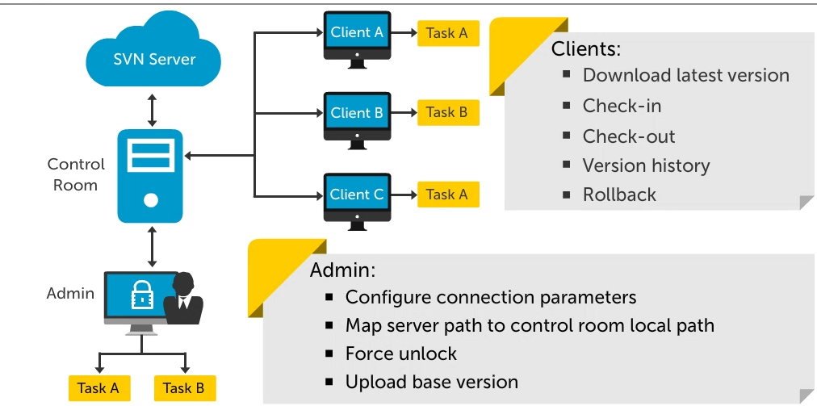

**Credentials Vault:**

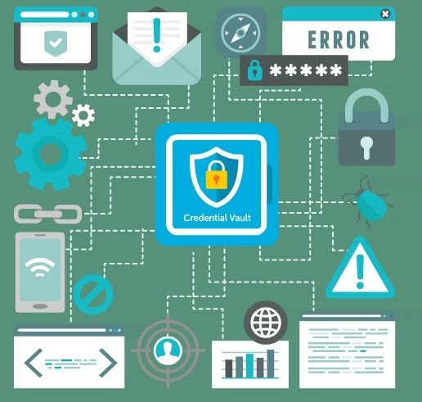

Centralized secured vault for sensitive data.

Credentials are encrypted using industry standard “Enterprise grade security”.

Recorder:

1. **Screen Recorder:** Standard recorder provides the easiest way to create simple automation processes as it captures all the mouse clicks and keystrokes that you perform while completing a process.
2. **Smart Recorder:** Also called Object Recorder, featuring Smart technology, is an advanced recorder that is ideal for Desktop applications.
3. **Web Recorder:** It is used for a process that is based on Web application and requires you to extract data from website.

